FOREIGN TRADE

Decree 1676/2014

Decree No. 509/2007 and Decree No. 25/2013. Modifications.

Bs. As., 25/09/2014

Published 06/10/2014

SEEN File No. S01: 0032242/2014 of the registry of the MINISTRY OF ECONOMY AND PUBLIC FINANCES, and

WHEREAS:

That through Decision No. 39 dated December 20, 2011 of the Common Market Council, authorizing the States Parties of the Southern Common Market (MERCOSUR) to increase transiently ONE HUNDRED (100) tariff positions, aliquots of import tax above the Common External tariff (CET) to imports from outside the region, not being able to be above the maximum bound tariff for each State Party to the WORLD TRADE ORGANIZATION (WTO).

That by Decree No. 25 dated January 22, 2013 the list of tariff items of Mercosur Common Nomenclature (NCM) in ARGENTINA for the transitory increase of aliquots corresponding to Import Duty Extrazone (DIE) was established, which amended Annex I of Decree No. 509 dated May 15, 2007, and its amendments.

It is necessary to replace the list of the Annex established by Decree No. 25/13 under the terms of Article 8 of the Community Regulation standard of the Common Market Council cited, in compliance with the regulated by Articles 3 and 4 of the same standard.

The Directorate General of Legal Affairs of the MINISTRY OF ECONOMY AND PUBLIC FINANCES has taken action within its jurisdiction.

That this decree was issued in exercise of the powers conferred by the NATIONAL EXECUTIVE POWER paragraphs 1 and 2 of Article 99 of the National Constitution, Articles 11, paragraph 2 and 12 of Law No. 22.415 (Customs Code) Act and its amendments and by Law No. 25,561 on Public Emergency and Exchange System Reform, extended by the similar No. 26,896.

Thus,

The PRESIDENT OF ARGENTINA

Decrees:

Section 1 - Modify Annex I of Decree No. 509 dated May 15, 2007, as amended, aliquots of Import Duty Extrazone (DIE) of the following tariff items of the Mercosur Common Nomenclature (NCM) by which in each case are as follows:

N.C.M. (MERCOSUR TARIFF SYSTME) | D.I.E. %
0810.50.00 | 10,0
1209.29.00 | 0,0
1604.14.10 | 16,0
1604.20.10 | 16,0
2002.90.90 | 14,0
2204.10.10 | 35,0
3604.10.00 | 20,0
3808.93.23 | 35,0
8480.41.00 | 35,0
8903.99.00 | 35,0

Article 2 - Hereby replaced the Annex of Decree No. 25 dated January 22, 2013 with the Annex which is an integral part of this measure.

Article 3 - Refer certified copy of this decree to the MINISTRY OF FOREIGN AFFAIRS aware as Coordinator of the National Section of the Common Market Group.

Article 4 - This Decree shall take effect from the day following its publication in the Official Gazette.

Article 5 - Communicated, published, transmitted to the National Official Registry and filed. - FERNANDEZ DE KIRCHNER. - Jorge M. Capitanich. - Axel Kicillof. - Deborah A. Giorgi.

Annex

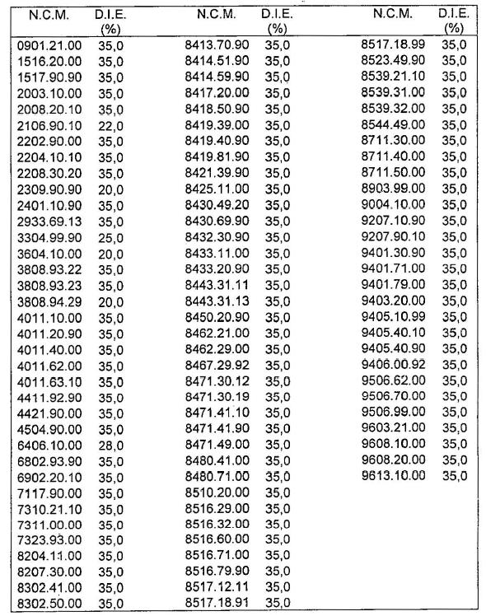
******
For the Spanish Text:
http://www.infoleg.gob.ar/infolegInternet/anexos/235000-239999/235857/norma.htm

